SELECT SUM(total_price) AS Total_Revenue FROM pizza_sales;
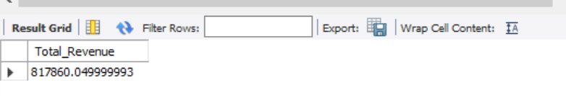

SELECT SUM(total_price) / COUNT(DISTINCT order_id) AS Avg_Order_Value FROM pizza_sales;
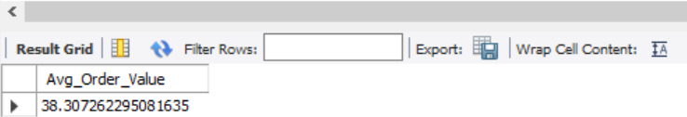

SELECT SUM(quantity) AS Toal_Pizza_Sold from pizza_sales

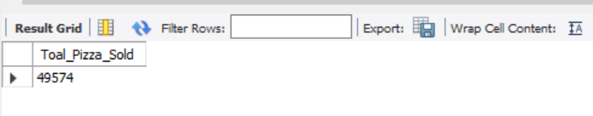

SELECT COUNT(DISTINCT order_id) AS Total_orders
from pizza_sales
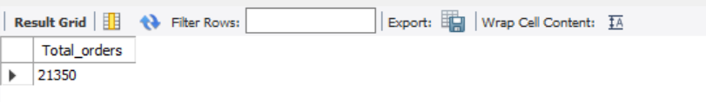

SELECT CAST(CAST(SUM(quantity) AS DECIMAL(10,2)) /
CAST(COUNT(DISTINCT order_id) AS DECIMAL(10,2)) AS DECIMAL(10,2)) AS Avg_Pizzas_Per_order from pizza_sales;
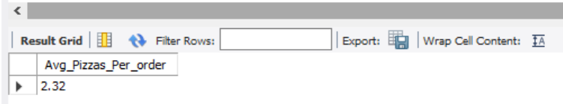

SELECT DAYNAME(order_date) as order_day, COUNT(DISTINCT order_id) AS Total_orders
from pizza_sales
GROUP BY DAYNAME(order_date);
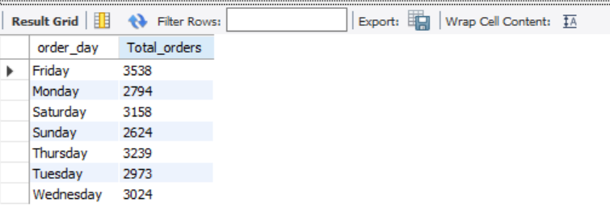

SELECT MONTHNAME(order_date) AS Month_Name, COUNT(DISTINCT order_id) AS total_orders
FROM pizza_sales
GROUP BY MONTHNAME(order_date)
ORDER BY total_orders DESC;
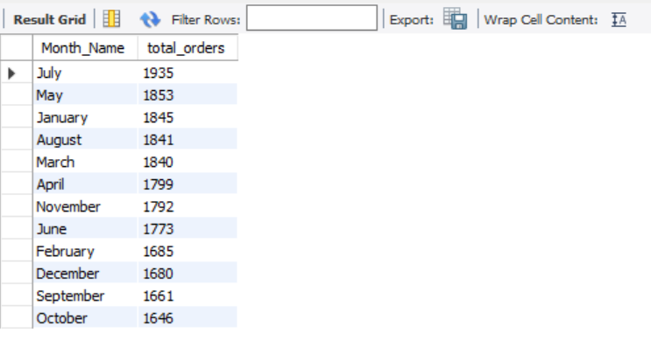

SELECT pizza_category, sum(total_price) as Total_Sales, sum(total_price) * 100 /
(SELECT sum(total_price) from pizza_sales WHERE MONTH(order_date) = 1) AS PCT
from pizza_sales
WHERE MONTH(order_date) = 1
GROUP BY pizza_category
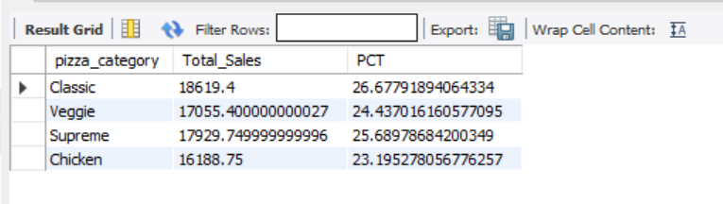
SELECT pizza_size, CAST(sum(total_price) AS DECIMAL(10,2)) as Total_Sales, CAST(sum(total_price) * 100 /
(SELECT sum(total_price) from pizza_sales WHERE QUARTER(order_date)=1) AS DECIMAL(10,2)) AS PCT
from pizza_sales
WHERE QUARTER(order_date)=1
GROUP BY pizza_size
ORDER BY PCT DESC;
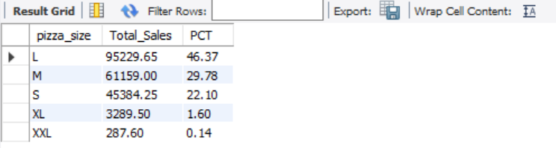

SELECT pizza_name, SUM(total_price) AS Total_Revenue FROM pizza_sales
GROUP BY pizza_name
ORDER BY Total_Revenue DESC
LIMIT 5;
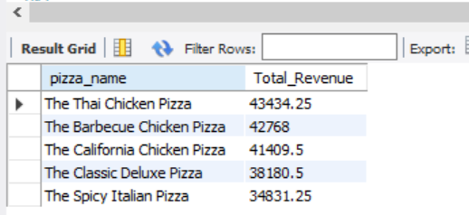

SELECT pizza_name, SUM(total_price) AS Total_Revenue FROM pizza_sales
GROUP BY pizza_name
ORDER BY Total_Revenue ASC
LIMIT 5;
